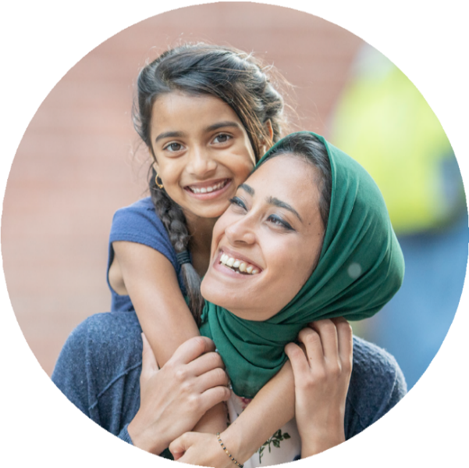
Find out more about raising happy, secure, and well-behaved children

Join our free, friendly and supportive course – ‘Positive Family Foundations’

This course is for
All parents and carers with children at
Stanton Bridge

What we do
- share information about child development
and parenting styles
- help with SEND issues
- give out practical resources and activities

‘It was great to listen to other parents. There were lots of ideas on the course - I found the section on Emotion Coaching really helped at home.’
- provide a welcoming and inclusive group
- have a drink and a snack

Where it is
In school - come to the school office

When it is

1.15 - 3.15pm every Wednesday from January 14th for ten weeks

How to join
Fill in the reply slip below and return to the school
To find out more email aeslifeskills@coventry.gov.uk or speak to Mrs Panesar in school

You can see all Family Learning courses https://coventry.gov.uk/adulted

*Assume you have a place unless you hear from us *
I would like a place on Stanton Bridge / Family Learning ‘Positive Family Foundations’ course
Your name………………………………….......Contact number…………………………






Child’s name ...……………………….………………...........Class….........……............

